Big-Data Analytics for Queensland Road Crashes with Spark: Severity Prediction and Risk Profiling

Aidan Tindale
School of EECS University of Queensland
INFS3208: Cloud Computing
Sen Wang
25/10/2025

Introduction
Road trauma imposes a large human and economic burden, and policymakers require timely, evidence-based insights to prioritise interventions. This project proposes a cloud-based big-data analytics pipeline that ingests Queensland road-crash records (2001–2024; ~400k rows) and uses Apache Spark to quantify fatality risk across crash contexts (speed environment, lighting, weather, alignment, traffic control, crash type), predict severe outcomes, discover high-risk profiles, and surface association rules that are actionable for road safety planning.
The motivation is threefold. Traditional desktop tooling struggles with the volume, heterogeneity, and iterative data preparation that real crash data entails. Morevoer, reproducible model training and evaluation require consistent environments and scalable compute that can be dialled up or down as needed. Finally, stakeholders increasingly expect modular data products such as cleaned datasets, features, models, and visualisations that can be re-used across analyses.
The project’s objectives and features are:
- Data engineering: enforce schema, handle missingness, normalise categories, and persist partitioned columnar data for fast access.
- Analytics at scale: perform four distinct Spark MLlib tasks: binary classification of fatal vs non-fatal, regression of monthly crash counts by context, clustering of risk profiles, and association-rule mining (FPGrowth).
- Decision-ready outputs: visualise fatality rates and model metrics; publish ranked “risk contexts” (e.g., dark, wet, 100–110 km/h, curve) with support/confidence/lift.
Single-node tools (Excel, desktop Python/R) read CSV row-by-row, lack predicate pushdown/column pruning, and cannot efficiently iterate over large joins or wide one-hot features. They also make concurrent experimentation and reproducible environments difficult. Cloud storage plus Spark’s distributed execution provide elastic parallelism, fault tolerance, and fast I/O via columnar formats. Managed services simplify operations so we can focus on analysis rather than infrastructure. Costs of such as project scale with use.

TECHNICAL SOLUTIONS
The application persists the raw CSV once, then writes a curated silver layer in Apache Parquet partitioned by year. A gold layer adds engineered features such as hour of day, day of week, peak-traffic flags, and speed-band labels. and normalises categorical values (e.g., lighting, surface, weather). Minimal imputation is applied (e.g., default 60 km/h for missing speeds). This medallion layout cleanly separates ingestion, cleansing, and analytics, reduces repeated I/O, and lets Spark SQL prune irrelevant partitions and columns.
The analytics stage uses Spark MLlib. For classification, the system trains logistic regression and gradient-boosted trees, reports AUPRC and AUROC on a held-out test window, and selects an operating point via the best-F1 threshold. For regression, it models monthly crash counts per context with gradient-boosted trees and reports RMSE/MAE. For unsupervised learning, it clusters context vectors with K-Means and reports silhouette scores with a simple k-selection sweep. For pattern discovery, it applies FP-Growth to prefixed, discretised crash attributes and ranks rules by support, confidence, and lift. Visualisations produced in Jupyter include precision–recall and ROC curves, confusion matrices, lift charts, true-vs-predicted and timeline plots for regression, cluster size and PCA projections, and formatted tables and charts of high-lift rules.
The solution runs on Google Cloud; storage uses Google Cloud Storage (or local disk during development) for raw, silver, and gold data. Compute uses Compute Engine VMs running Spark in standalone mode, so the cluster can be started only for short, scheduled jobs. Optional Cloud SQL (PostgreSQL) can host small reference tables, although Parquet “tables” suffice here. Costs are modest: an e2-standard-4 VM is a few cents per minute; forty hours of monthly use keeps compute in roughly $10–$30 depending on node count. Cloud Storage Standard is a few cents per GB per month; even at tens of GB, storage is about $1–$3. Persistent disks add only a few dollars monthly. Disciplined shutdown of compute is the largest lever.

Architecture Design
Ingestion uploads the crash CSV to Cloud Storage. The curation job casts timestamps and numerics, normalises categories, removes duplicates, derives calendar year, and writes year-partitioned Parquet to the silver path. The feature job derives temporal fields and speed bands and writes the gold path optimised for ML. The analysis job first computes descriptive metrics with Spark SQL (e.g., fatality rates by crash type and by lighting×speed), then trains and evaluates classification and regression with a temporal split (e.g., train ≤2019, validate 2020–2022, test 2023–2024) to avoid leakage and reflect deployment. It also produces clusters and association rules, and exports trained models and artefacts.
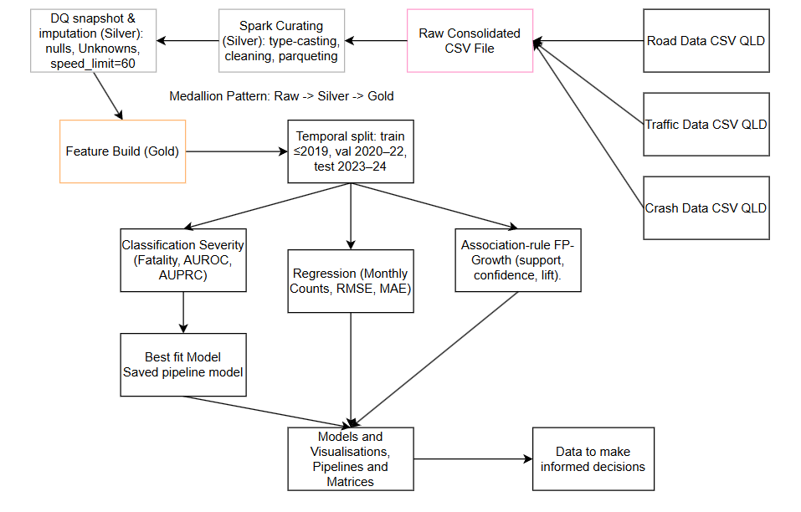
Figure 1: Project workflow diagram. Raw crash CSV is curated to Silver Parquet, features are built into a Gold dataset, then a temporal split (train/val/test) feeds three analytics branches; classification (AUPRC/AUROC), regression (RMSE/MAE), and association rules (support/confidence/lift), whose outputs combine into saved models and visualisations for data-driven decisions.
This design isolates expensive stages, exploits columnar storage and partition pruning, and scales compute up briefly for full-history training before scaling down to zero. It also supports reproducibility: each stage reads from and writes to immutable paths, and the same code runs locally for development and on the cloud for full data. The expected outcome is a maintainable, cost-aware pipeline that delivers actionable safety insights impractical to obtain on a single machine.

